Mead Lake
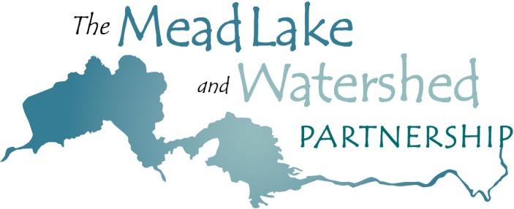
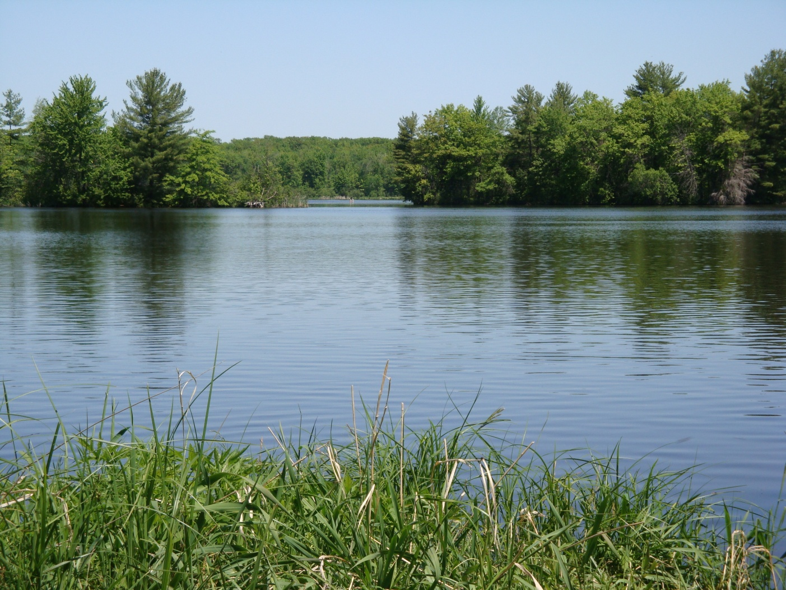
Management Plan

March 2010
Updated April 2025
Table of Contents

Section Page
Acknowledgements..……………………………………….2
*Updated Management Goals and Objectives .….3
*Prologue..……………………………………………….……4
Original Introduction..…………………………………….10
Background.………………………………………………….11
2009 Mead Lake Sociological Surveys.…….……….12
Total Maximum Daily Load (TMDL)………………….14
*Fishery…………………………………………………………15
*Aquatic Plant Community ………………………….….16
Septic Systems …………………………….…………….…16
Original Management Goals and Objectives ….….17
*Appendices List ……………………………………………23
*Dissolved Oxygen levels .…..………………………….24
*Lake Map of Test Areas .…………………………….…26
*Trophic State Index, Phosphorus, Chlorophyll-a.26
*Surface Water Planning Grant Application.……….27
*Water Sampling Laboratory Expense..….………….27
*Technical Data NanoBubble Aeration..….………….28
*Aquatic Plant Community Review ……………………29
*References….….…………………………………………….32
*Public and WDNR Comment……………………………33

Acknowledgements

The Mead Lake Management Plan is a cooperative effort of the members of the Mead Lake and Watershed Partnership:
Citizens of the Mead Lake Watershed
*Mead Township
Mead Lake District
Clark County Land Conservation Department
Natural Resources Conservation Service
Wisconsin Department of Natural Resources
University of Wisconsin – Extension
*Eau Claire River Watershed Association
*West Central Wisconsin Regional Planning Commission
Thanks go to the Stakeholder Leadership Team members who helped write this plan and participated in the meetings leading up to its completion. Thanks also to the Town of Mead, the US Army Corps of Engineers, and the University of Wisconsin-Stevens Point.
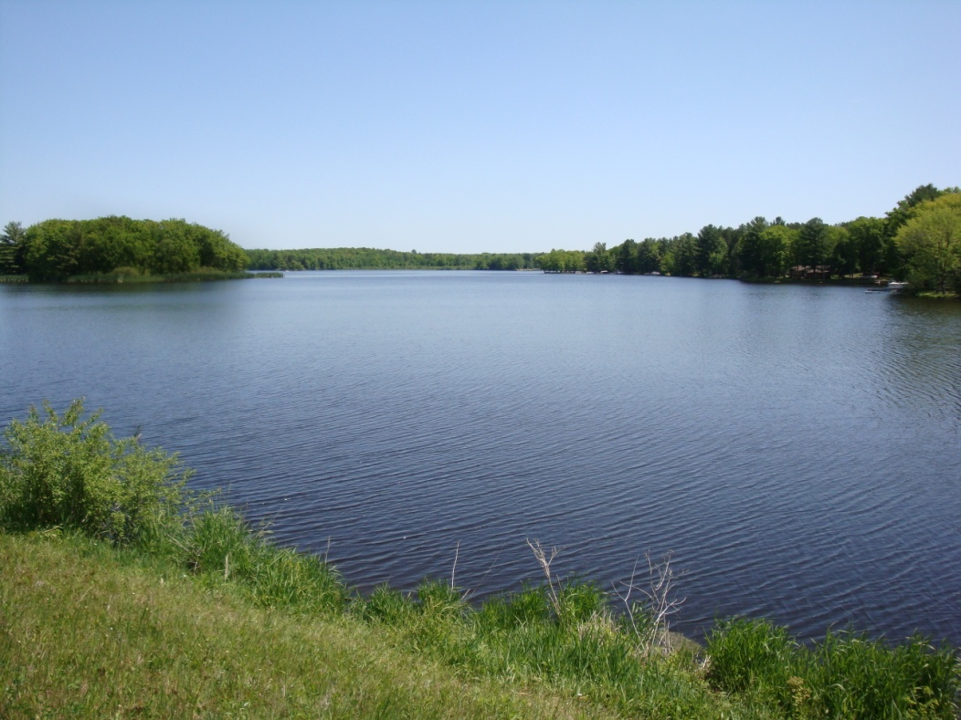

*indicates addendum, annotation or revision to update of Mead Lake Management Plan 2025-2035

Updated Mead Lake Management Goals and Objectives
2025 through 2035

The following 2025 through 2035 goals and objectives supersede goals and objectives published in the Mead Lake Management Plan of 2010. See URL, references p29

Prologue: Update to the Mead Lake Management Plan
The State of Wisconsin has established surface water quality criteria of 40 µg/L for phosphorus and 20 µg/L for chlorophyll-a. During the 2023–2024 monitoring period, Mead Lake exceeded these standards significantly, with phosphorus concentrations nearly five times the limit and chlorophyll-a levels approximately four times higher. The average phosphorus concentration reached 189 µg/L—a 46% increase compared to the 130 µg/L concentrations recorded in 2002–2003.
In addition, 2024 data revealed that the lake’s bottom waters remained anoxic throughout the core summer months. These oxygen-depleted conditions, driven by nutrient over-enrichment, hinder the natural decomposition of organic matter and negatively affect fish habitat. This ongoing cycle of eutrophication has left Mead Lake in an impaired ecological state.
In response, and in collaboration with the Wisconsin Department of Natural Resources (WDNR), the Mead Lake District will launch a two-year lake rehabilitation initiative in 2025–2026 titled Long Live Mead Lake, approved in 2024. This program will evaluate the impact of NanoBubble concentrated oxygen aeration technology on water quality and sediment conditions.
The system uses a shore-based oxygen concentrator that circulates lake water and returns it with elevated dissolved oxygen levels. The pilot study will begin in a one-acre bay located along the south shore on the east end of the lake. This test site will assess whether targeted oxygenation improves organic matter decomposition and reduces blue-green algal blooms. A similarly sized control site, without aeration, will be established nearby to allow for comparative analysis.
Both the test and control sites will be monitored from May through September, with pre- and post-intervention assessments. Water samples will be analyzed for phosphorus, chlorophyll-a, algae, and zooplankton. Dissolved oxygen will be regularly measured, and sediment samples will be tested for particle size, moisture content, and organic composition.
To support this effort, the Mead Lake District submitted a Surface Water Planning Grant application in November 2024 to help offset laboratory testing costs (see Appendix, p. 27).
This initiative represents a key component of the updated Mead Lake Management Plan for 2025–2035. While the original plan, published in 2010, remains a valuable reference and has received various technical updates, the revised version integrates current data and emerging technologies to guide lake improvement efforts over the next decade.
A summary of the addendums, revisions and annotations is as follows:
Page 5-9, Updated lake management plans for 2025-2035
Page 10, Amendment to owned properties
Page 12, Annotation, informal survey
Page 14, Addendum - WDNR NR 102.56 Water Quality Standards For Wisconsin Surface Waters
Page 15, Revision to date of Fisheries survey
Page 17, Annotation on supersession of 2010 Goals and Objectives
Page 17, Annotation to change of phosphorus concentration
Page 18, Addendum to change of name for grant
Page 22, Annotation to completion of public beach and no wake markers
Page 23-27, Appendices of data of dissolved oxygen, phosphorus, and Chlorophyll-a, annual expense and volunteer donation for lake water testing
Page 28, Technical Data NanoBubble Aeration
Page 29, Addendum of References
Management Goals and Objectives – January 2025
Mead Lake is currently listed as an impaired eutrophic water body on the State of Wisconsin’s Impaired Waters List. Phosphorus and sediment, primarily entering the lake from the South Fork of the Eau Claire River, have led to elevated nutrient levels and frequent summer algal blooms.
According to Wisconsin surface water quality criteria, phosphorus should not exceed 40 µg/L and chlorophyll-a should remain below 20 µg/L. However, during the 2023–2024 monitoring period, Mead Lake recorded phosphorus concentrations five times the allowable limit and chlorophyll-a levels four times the standard. These values represent a 46% increase from 2002–2003 data, which recorded average concentrations around 130 µg/L. Additionally, 2024 data confirmed that bottom waters remained anoxic throughout the summer, further indicating a persistent eutrophic and impaired state. Anoxic conditions hinder the natural decomposition of organic matter and degrade fish habitat.
In response, the Mead Lake District approved the introduction of NanoBubble aeration technology during its 2024 annual meeting. The goal is to improve lake water quality through increased dissolved oxygen levels. Beginning in June 2025, the district will launch a two-year pilot program to evaluate the feasibility and effectiveness of this technology in reducing sediment accumulation (muck) and mitigating harmful algal blooms.
NanoBubble technology works by generating microscopic air bubbles that supersaturate water with oxygen. A shore-based aeration system circulates lake water, enriches it with ambient oxygen, and returns it to the lake. This increased oxygenation is expected to enhance the natural breakdown of organic material in bottom sediments, reduce phosphorus and chlorophyll-a levels, suppress algal blooms, and improve overall water clarity. All equipment is land-based, and no intake or discharge components are affixed to the lakebed.
The pilot site will be a one-acre area located on the east end of Mead Lake’s south shore. A control site, approximately 100 yards to the east, will be used to evaluate results against untreated conditions (see map, p. 26). The project aligns with the broader goals of the Eau Claire River Watershed’s Nine Key Element (9KE) Plan. Mead Lake is situated within Hydrologic Unit Code (HUC) 0705006, a region targeted by the U.S. Environmental Protection Agency’s 2017 9KE Plan titled Healthy Soils & Healthy Waters: A Community Strategy for the Eau Claire River Watershed. Mead Lake District representatives participated in developing this plan, which recognizes that over 79% of the watershed’s impaired water bodies are affected by total phosphorus pollution—Mead Lake included.
The 9KE Plan also identified the HUC-12 sub-watersheds upstream of Mead Lake as having some of the highest phosphorus-loading rates per acre. While long-term land use changes are critical, in-lake interventions like NanoBubble aeration are valuable tools that can reduce symptoms such as algal blooms and assist in meeting watershed-wide pollution reduction goals.
To comply with Wisconsin DNR regulations, the project will operate under an annual NR 109 permit, which includes a rigorous monitoring program. Water and sediment samples will be collected bi-weekly during each growing season and sent to a certified laboratory for analysis. The program will track 14 key metrics, including phosphorus, chlorophyll-a, dissolved oxygen, nitrogen, ammonia, algae, zooplankton, and sediment characteristics. Full data requirements are outlined in Appendix Table (p. 27).
Following the completion of this two-year pilot, statistically significant changes in nutrient levels, sediment composition, biological communities, dissolved oxygen, and water clarity will inform adaptive lake management strategies. These strategies will support surface water restoration efforts between 2027 and 2030.
With this understanding, the Mead Lake District will begin implementing Goals 1, 2, and 3 of its updated Lake Management Plan in June 2025. These initiatives will launch a comprehensive program focused on long-term surface water restoration and protection, built on six key strategic elements.
To support the achievement of Goals 1, 2, and 3 of the Mead Lake Management Plan, the following six key elements will guide lake restoration and protection efforts beginning in June 2025:
- Collaborative Watershed Management
Partner with Clark County to support ongoing efforts aimed at reducing agricultural phosphorus loading from the South Fork of the Eau Claire River watershed into Mead Lake.
- Real-Time Water Flow and Quality Monitoring
In collaboration with Clark County Land Conservation, Parks and Forestry, and the Eau Claire River Watershed Association (ECRWA), install continuous flow and water chemistry monitoring technology at the Mead Lake dam. Collected data will be accessible in real time to support water monitoring across all downstream water bodies.
- Lake Restoration Through NanoBubble Aeration
Launch a multi-year, two-phase pilot program utilizing NanoBubble oxygenation technology to improve water quality and sediment conditions.
  - The project includes a one-acre test site and a similarly sized control site.
  - It will follow Wisconsin DNR NR 109 permit guidelines, requiring biweekly sampling and laboratory analysis of water chemistry, biology, and bottom sediment.
  - In November 2024, the Mead Lake District applied for a Surface Water Planning Grant to support lab testing costs. This application was not approved for 2025.

- Updated Bathymetric Mapping
Complete a modern bathymetric (lake bottom contour) map of Mead Lake to inform habitat restoration and sediment management strategies.
  - Initial mapping was partially completed in 2024.

- Healthy Lakes Shoreline Vegetation Initiatives
Implement 2–3 Healthy Lakes projects aimed at restoring native riparian vegetation. WDNR grants will be pursued to help offset shoreline property owner expenses.
- Fish Habitat Enhancement Program
Initiate a late-season fish habitat improvement project, including the strategic placement of fish cribs to support aquatic species diversity and spawning areas.
Mead Lake Management Plan - 2025-2035

Goal 1: Improve water quality and decrease the frequency and intensity of algae blooms, by decreasing sediment and phosphorus inputs to the lake.
Strategy: Promote Protection and Restoration of the Watershed and Lake.
Mead Lake is delisted from the state impaired waters list.
Objectives and Recommendations | 10 Year Milestones | Lead Entity/s | Resources
- Work cooperatively with Clark County on their efforts to control agricultural Phosphorous coming into the lake via the south fork of the Eau Claire River watershed. | Ongoing | Clark County  Mead Lake District | Eau Claire Watershed Coalition
- Install continuous monitoring gauges and calibrate for water flow, total phosphorus, and fine suspended solid loads.  Support and coordinate monitoring efforts to downstream Lake Districts. | 1st - 2nd years  On going | Clark County  ECRWA  Mead Lake District | ECRWA - Eau Claire River Watershed Association  Eau Claire Watershed Coalition  WDNR Staff / Lake Planning Grant
- Conduct coring and survey sediment deposition characteristics of lake sediment and develop high quality bathymetric maps of Mead Lake. | 1st – 3rd years  On going | Mead Lake District | WDNR Staff / Lake Planning Grant  ECRWA - Eau Claire River Watershed Association
- Establish an aerial record of changes along the watershed and determine erosion hotspots. | 2nd – 10th | Mead Lake District | Clark County  ECRWA - Eau Claire River Watershed Association
- Promote surface water restoration and rehabilitation using aeration technology.  Develop optional aeration program for treatment of the lake’s largest and deepest areas. | 1st - 5th and as project results dictate | Mead Lake District | WDNR Staff  ECRWA - Eau Claire River Watershed Association
- Groundwater Testing.  Maintain objective as written in Management plan. | As needed or required | Mead Lake District | Existing Mead Lake Management plan
- Education.  Promote events which bring awareness and education to understanding Mead Lake’s conditions, needs and improvements. | Ongoing | Mead Lake District | WDNR Staff / Lake Education Grant  Clark County  ECRWA - Eau Claire River Watershed Association  Lake Eau Claire District  Lake Altoona District
- Maintain participation in routine meetings of the Eau Claire River Watershed Technical Committee and Eau Claire River Watershed Coalition. | Ongoing | Mead Lake District | ECRWA - Eau Claire River Watershed Association  Lake Eau Claire District  Lake Altoona District  Clark County

Mead Lake Management Plan - 2025-2035 – Con’t
Goal 2: Increase natural vegetation to produce biologically productive shore land that minimizes erosion and enhances natural aesthetics.
Strategy: Actively Promote WDNR Healthy Lakes and Rivers Grant program.
Objectives and Recommendations | 10 Year Milestones | Lead Entity/s | Resources
- Survey Current Lakeshore Riparian Conditions as started in 2024. | 1st – 2nd | Mead Lake District  WDNR Staff | WDNR Staff / Lake Planning Grant  Existing Mead Lake Management plan
- Installation of Vegetated Shore Land Buffers. | 1st through Ongoing | Mead Lake District  WDNR Staff | WDNR Staff / Healthy Lakes and Rivers Grant  Existing Mead Lake Management plan
- Education  Promote events which bring awareness and education to understanding Mead Lake’s conditions, needs and improvements. | Ongoing | Mead Lake District | WDNR Staff / Lake Education Grant  Golden Sands RC&D  Existing Mead Lake Management plan
- Maintain participation in routine meetings of the Eau Claire River Watershed Technical Committee and Eau Claire River Watershed Coalition. | Ongoing | Mead Lake District | ECRWA - Eau Claire Watershed Association  Lake Eau Claire District  Lake Altoona District  Clark County

Goal 3: Maintain healthy fishery with desirable species, and a diverse native aquatic plant community.
Strategy: Promote A More Self Sustaining Fishery.
Objectives and Recommendations | 10 Year Milestones | Lead Entity/s | Resources
- New Lake Map. | 1st | Mead Lake District | ECRWA - Eau Claire Watershed Association
- Promote events such as placement of fish cribs, fish sticks and other fish attractants to improve spawning habitat and maintain a healthy fishery. | Ongoing | Mead Lake District | WDNR Staff / Healthy Lakes and Rivers Grant
- Maintain participation in routine meetings of the Eau Claire River Watershed Technical Committee and Eau Claire River Watershed Coalition. | Ongoing | Mead Lake District | ECRWA - Eau Claire Watershed Association  Lake Eau Claire District  Lake Altoona District  Clark County
- Education.  Promote events which bring awareness and education to understanding Mead Lake’s conditions, needs and improvements. | Ongoing | Mead Lake District | WDNR Staff / Lake Education Grant

Mead Lake Management Plan - 2025-2035 – con’t
Goal 4: Prevent expansion and new infestation of invasive and exotic species.
Objectives and Recommendations | 10 Year Milestones | Lead Entity/s | Resources
- Monitoring.  Promote through WDNR Directed Lakes initiative. | 1st and 2nd  2030  2035 | Mead Lake District  WDNR | WDNR Staff / AIS Planning Grant  Golden Sands RC&D
- Education.  Promote events which bring awareness and education to understanding Mead Lake’s conditions, needs and improvements. | Continuous | Mead Lake District | WDNR Staff / Lake Education Grant  Golden Sands RC&D
- Maintain participation in routine meetings of the Eau Claire River Watershed Technical Committee and Eau Claire River Watershed Coalition. | Ongoing | Mead Lake District | ECRWA - Eau Claire Watershed Association  Lake Eau Claire District  Lake Altoona District  Clark County

Goal 5: Provide safe, diverse recreational opportunities for all.
Objectives and Recommendations | 10 Year Milestones | Lead Entity/s | Resources
- Beach.  User friendly beach is completed by Clark County. | As needed | Clark County | Clark County  Existing Mead Lake Management plan
- Boating Regulations. | Ongoing as may be needed | Clark County  Mead Lake District | Existing Mead Lake Management plan  Clark County  Mead Township  WDNR Staff / Grants
- Maintain participation in routine meetings of the Eau Claire River Watershed Technical Committee and Eau Claire River Watershed Coalition. | Ongoing | Mead Lake District | ECRWA- Eau Claire Watershed Association  Lake Eau Claire District  Lake Altoona District  Clark County
- Education.  Promote events which bring awareness and education to understanding Mead Lake’s conditions, needs and improvements. | Ongoing | Mead Lake District | WDNR Staff / Lake Education Grant  Clark County  Golden Sands RC&D

Introduction
Since the Mead Dam was completed in 1951, Mead Lake has been used by residents and visitors for fishing, swimming, boating, camping, family events, and many other recreational activities. Even before Mead Lake existed, enthusiasm for the lake was present in the local population. In 1948, a year before construction on the dam was scheduled to begin, twenty-six people had already applied for leases for lake property and had put down deposits. The location of Mead Lake, far from most metropolitan areas and surrounded by mostly forest, makes it an idyllic location to relax, experience nature, and get together with family and friends. Cabins and residences around the lake have been built over the years, and now number around 130*. *(138 in 2024) For more than fifty years, residents of the lake and outside visitors have been enjoying the pleasures Mead Lake has to offer.
Managing and improving Mead Lake has been an ongoing process since its creation. Dam repairs have been made several times over the years. A campground was added in the 1960s, with new boat docks following in years after. In 1959 the Mead Lake Club was organized, and during the course of their existence, promoted many improvements at the lake. In the 1990s, the Club became the Mead Lake Association, eventually becoming the Mead Lake District in 2001. Many interesting details about the creation of the lake can be found in the document “A Collection of Mead Lake Nostalgia”, available at MeadLake.com*
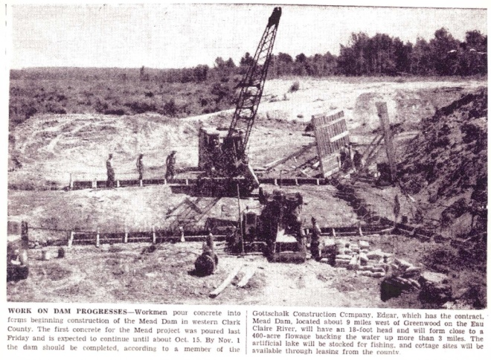
Nuisance algae blooms have been an issue for much of Mead Lake’s existence. Records show that as early as 1971 attempts were made to control such blooms using chemical treatment and lake draw-downs. In November 2008, water quality issues in the lake brought concerned stakeholders together in Greenwood, WI, just east of Mead Lake. At this meeting, people brought up several dozen issues of concern regarding the lake and also heard from experts on some of the science behind the algae problems. At the conclusion of the meeting, people were asked to sign up to be part of an organized partnership effort to address these concerns. The group came to be known as the Mead Lake and Watershed Partnership (the Partnership). A Stakeholder Leadership Team formed within the Partnership and began meeting monthly. The Partnership includes landowners from Mead Lake and its watershed, the Mead Lake District, Clark County Land Conservation Department, Natural Resources Conservation Service, Wisconsin Department of Natural Resources (WDNR), and University of Wisconsin-Extension.
Newspaper photograph of Mead Dam construction, likely from 1949.

“The Mead Lake & Watershed Partnership’s mission is to create and implement strategies to raise awareness of the interdependent link between people, land and water, and to protect and restore Mead Lake and its watershed in order to preserve the ecological, recreational and aesthetic value of these resources for future generations.”

Many studies on Mead Lake in recent years have looked at aquatic plants, invasive species, shore land habitat and erosion, fisheries, and sanitary sewer systems. These studies demonstrated the need for an organized effort to address water quality and other concerns at Mead Lake. As the Partnership began to discuss these concerns, it became clear that a Lake Management Plan was a necessary first step towards addressing them.
This plan will be reviewed and updated by the Partnership on an annual basis.
Background
One of the earliest references found regarding the creation of Mead Lake dates to March of 1948, when Clark County applied to the Public Service Commission of Wisconsin in Madison for a permit to construct a dam on the South Fork Eau Claire River for recreational purposes. The dam was completed in 1951, forming what is now the 320 acre Mead Lake in the Town of Mead, west of Greenwood. The lake has a mean depth of about five feet and maximum depths of around sixteen feet. The watershed draining to Mead Lake is approximately 64,000 acres, or about 100 square miles in size. The majority of the land use in the watershed is cropland (see land cover map, page 4). There are no incorporated municipalities in the watershed, and a good portion of the agricultural population is made up of Amish and Mennonite communities, some only arriving in the area in the last twenty to thirty years. The main tributary to Mead Lake is the South Fork Eau Claire River, with other smaller tributaries such as Rocky Run.
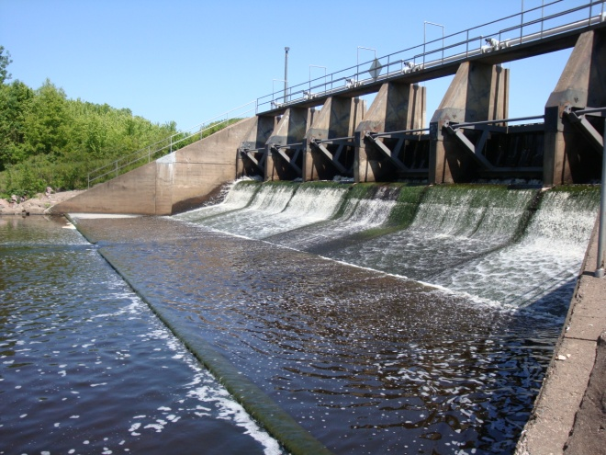
The dam at Mead Lake in summer 2009
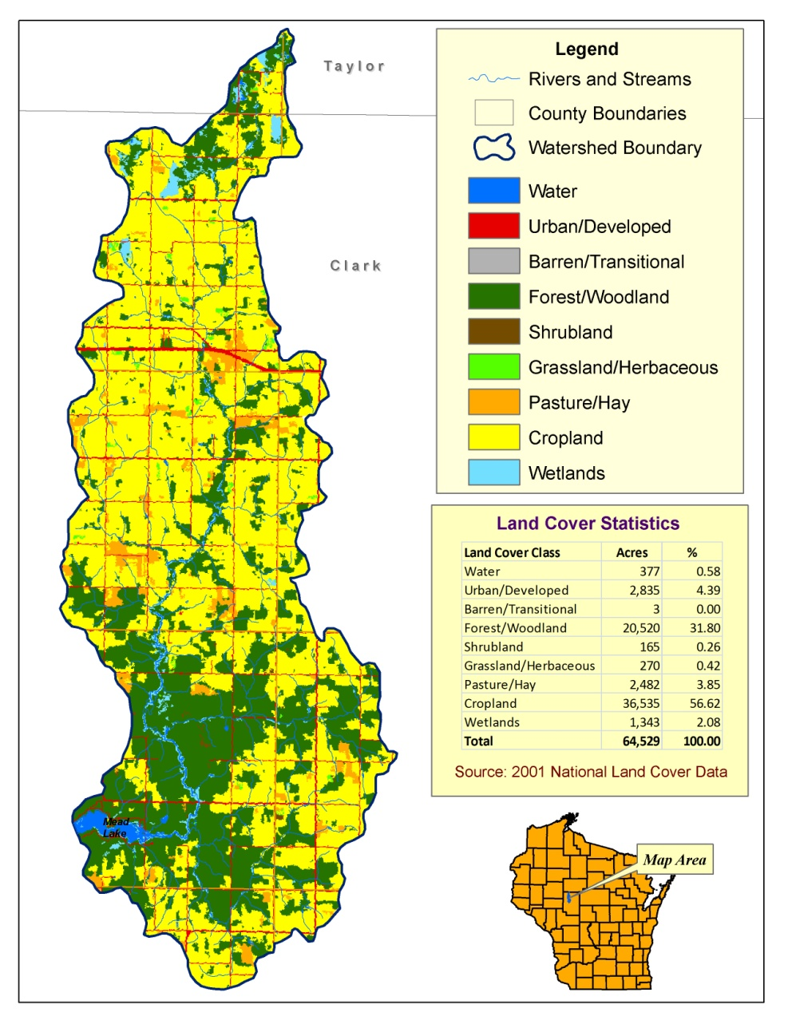
Mead Lake is considered highly eutrophic (nutrient-rich), and the lake has been listed on Wisconsin’s 303d list of impaired waters in 1998 due to sediment and phosphorus. From 2002 to 2003, the US Army Corps of Engineers did a study of Mead Lake’s water quality. Results from this study were used to develop the Total Maximum Daily Load (TMDL) written by WDNR and approved by the US Environmental Protection Agency in 2008. The TMDL document defines prescriptive goals for phosphorus load reductions to the lake. Since phosphorus is the principle nutrient contributing to the growth of algae and cyanobacteria, lower phosphorus levels would lead to reductions in the frequency and extent of unwanted algae blooms. Cyanobacteria, sometimes called “blue-green algae”, release dangerous toxins into the water that can cause illness and even death in pets and people if ingested in high enough quantities. Surveys conducted in 2009 (and informal 2023/2024)* indicate that people avoid recreational activities such as swimming and fishing when algal blooms are present.
An improvement in water quality will increase the recreational and aesthetic benefits of Mead Lake, as well as the aquatic life found in the lake and its tributaries. Furthermore, any efforts to control phosphorus in the lake’s watershed will likely decrease the amount of sediment flowing into the lake, thus increasing the lake’s lifespan. Controlling the amount of phosphorus and sediment flowing into the lake will take a coordinated effort between those living at the lake and those living farther up in the watershed. Pollution control efforts implemented now will reduce the need for pollution control later; therefore, society’s cost for clean-up will be less. Erosion from fields and shorelines, barnyard runoff, manure management, and septic systems are just some of the issues that need to be addressed.
2009 Mead Lake Sociological Surveys
During summer 2009, the Partnership worked with staff at the Environmental Resources Center at the University of Wisconsin-Madison and staff at WDNR to develop sociological surveys designed to survey people living at the lake and those visiting the lake. Survey questions focused on how people used the lake and how they perceived the water quality. They were asked their opinions regarding the causes of poor water quality, how water quality could be improved, and their willingness to participate in such efforts. Lake property owners were also asked how they managed their property to help minimize any negative impacts on the lake.
Lakefront Property Owner Survey
The mail survey of lake residents was conducted from late August through September 2009. Of 132 surveys mailed out to all lakefront property owners, 116 were returned, for a response rate of 88%, suggesting that a large portion of Mead Lake residents are interested in the health of the lake.
According to the survey, the top four recreational activities in which lake residents participated in the previous twelve months were; scenic viewing (70%), motorized boating (61%), fishing (53%) and wildlife viewing (53%).
Graph showing that a large majority of Mead Lake residents are concerned about summer algal blooms. (Blasczyk and Summers)
Among lake residents there was a widely held view that water quality was poor for swimming and other recreational activities during much of the summer due to the presence of algal blooms. It was also apparent that a majority of lake residents (72%) said they’d be willing to change how they manage their property if it would improve the water quality of the lake. However, the majority of respondents held negative views toward installing vegetated buffers between their property and the shore. Only 31% of respondents had some type of vegetated buffer on their property. Nearly 60% of those who had a lawn on their property did not use fertilizer, and another 28% were already using a low- or no-phosphorus type of fertilizer.
The typical respondent to the survey was a seasonal lake resident who spent weekends, especially during the summer, at Mead Lake, rather than a permanent, year-round resident.
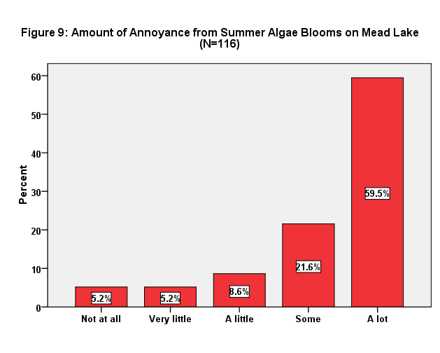
The average number of years that a respondent owned their property was 18 years.

Additionally, a majority of respondents had some knowledge of improvement efforts focused on water quality at the lake. Twenty-four of the 116 respondents had attended at least one of the monthly meetings of the Partnership’s Stakeholder Leadership Team.
Lake Visitors Intercept Survey
During the last three weeks of summer in 2009, leading up to and including Labor Day weekend, volunteers (mostly from the Mead Lake District) conducted face-to-face surveys with visitors to the lake. During this time, 99 interviews were completed.
The largest percentage of visitors (41%), were from Clark County. There were many other visitors from other nearby counties including Eau Claire, Marathon and Wood. People also came from places much farther away. Distances traveled ranged from 1 to 625 miles, with the median distance being 35 miles. Most of those surveyed visited Mead Lake many times during the previous 12 months.
The activities that most people participated in over the previous 12 months were scenic viewing and open-water fishing, followed by motorized boating and wildlife viewing. The two major reasons for their visit on the day of the survey were fishing and camping.
An overwhelming majority (91%) of survey respondents were either very concerned or somewhat concerned about the water quality of the lake. About 40% of those interviewed said they had avoided certain recreational activities during past visits because of poor water quality. Swimming was the most common activity avoided. When survey participants were asked to explain why they avoided such activities, the most common answers were poor water quality in general, or “green water.”
Further survey work is being conducted in the watershed during spring and summer of *2010 to determine the interests/needs/concerns of producers in the watershed. Since farmers will play a key role in phosphorus and sediment reduction strategies it’s important to understand their concerns so that any type of reduction programs maximize producer cooperation.*Addendum- Not yet compete
Total Maximum Daily Load (TMDL)
In 2008, WDNR completed a Total Maximum Daily Load, or TMDL, for Mead Lake. A TMDL is a document that specifies the maximum amount of a particular pollutant a water body can receive and still meet water quality standards. The results of this TMDL were based on surface water monitoring conducted in the watershed, as well as hydrologic modeling of how land use affects the watershed. Although the main issue with Mead Lake is phosphorus and sediment inputs, the State of Wisconsin currently does not have numeric water quality criteria for phosphorus or sediment.*
*Addendum 2025
WDNR NR 102.56 Water Quality Standards For Wisconsin Surface Waters establishes criteria of 40 µg/L for Phosphorus and 20 µg/L for Chlorophyll-a. During the 2023–2024 monitoring period, Mead Lake exceeded these standards significantly, with phosphorus concentrations nearly five times the limit and chlorophyll-a levels approximately four times higher.
However, the State does have a water quality standard for pH. The pH of a lake is closely correlated to the presence of chlorophyll a, which is influenced by the amount of phosphorus entering a body of water. A water body with high levels of chlorophyll a (a basic indicator of algal biomass) will have a correspondingly high pH. Therefore, if Mead Lake can achieve the water quality standard for pH, it will have fewer and less intense algal blooms.
For the Mead Lake TMDL, water monitoring was conducted in the lake and in the South Fork Eau Claire River in 2002-2003. The study focused on external pollutant loading (suspended sediments and nutrients) from the South Fork Eau Claire River, internal movement of phosphorus from lake sediments into the water column, and general in-lake water quality. The study found that on average, 83% of phosphorus loading to the lake came from direct drainage from the lake’s tributaries. Internal loading from phosphorus already present in the bottom sediments in the lake averaged only 17%. A Soil and Water Analysis Tool (SWAT) model was used to determine possible sources of the loading from tributaries, how such loading affects the lake, and how decreasing these loads will positively affect water quality.
A TMDL usually calls for reductions of the pollutant of concern from both point sources (such as an effluent pipe from a waste water treatment plant) and non-point sources (such as agricultural fields or residential lawns). Since there are no municipalities or large industries in the Mead Lake watershed, there are no point sources of pollution. Therefore, reductions of phosphorus and sediment will have to come from non-point sources. The recommended seasonal (growing season) reduction written into the TMDL for Mead Lake, and based on the monitoring and modeling work, is a 30% reduction of sediment and a 30% reduction of phosphorus inputs to Mead Lake. Such reductions should decrease the frequency and intensity of algal blooms, and improve the water quality of Mead Lake.
Once phosphorus contributions from the Lake’s tributaries are significantly decreased, then the in-lake phosphorus contributions from lake sediments can be addressed. The most common method for this would be treating the sediment with alum, sealing the phosphorus beneath the alum layer and making it unavailable to the water column.
Fishery
Spring collection of fish data has taken place on Mead Lake often in the last few decades; 1980, ’85, ’87, ’95, ’96, 2004, ’08 and ’16*. Pan fish, game fish, and carp have all been surveyed. *Revision to add 2016 No report was available for 2016.
Generally, the condition of the fishery is good. Local fishermen indicate improvement in 2024 to sizes of Yellow Perch. White and Black Crappie remain abundant*. Addendum - WDNR survey planned in 2025
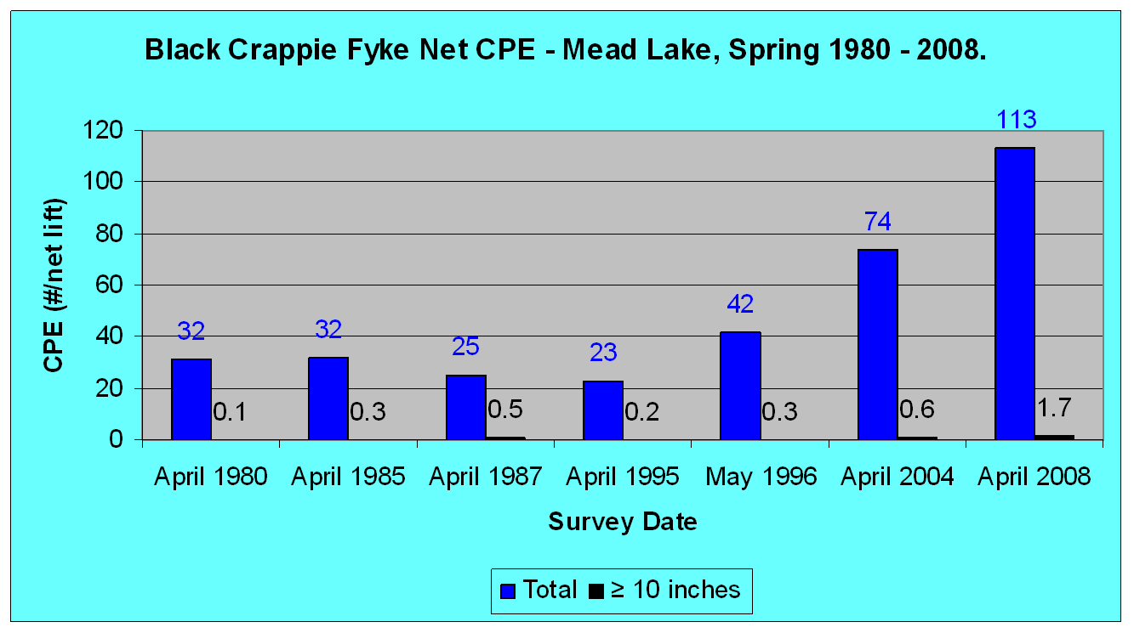
In the 2008 survey, crappies were numerous
Black crappie survey history at Mead Lake over the past 30 years. (Courtesy of Dan Hatleli – WDNR)

and of good size. Bluegills showed good size structure but were fewer in number compared to years past. Perch showed a high density but poor size. Walleye density was typical compared to years past, which is to be expected since walleye are stocked annually in the lake. Musky showed nice sizes, and are being stocked every other year. The WDNR recommends checking recruitment of largemouth bass, as numbers are low. Carp showed a low density in the 2008 survey, and are not considered a major problem. Carp have been denser in the lake in years past, and many area lakes currently have challenges with carp. However, a few carp is good for both fish diversity and the aquatic plant community in the lake.
The WDNR recommends continued stocking of walleye and musky, along with winter monitoring of dissolved oxygen. Current fishing regulations appear adequate. The fishery at Mead Lake will be surveyed again in 2012*Addendum - WDNR Survey planned for 2025. Musky and Walleye have been stocked at even numbered years 2012-2024.
Aquatic Plant Community
The most recent complete study of the aquatic plant community in Mead Lake, for which complete analysis is available, was done in 1998. From this study, seventeen separate aquatic plants were present in the lake, and a “moderate” rating of diversity was given. Of the seventeen plants, only one was a non-native and considered invasive; P. crispus, or curly leaf pondweed.
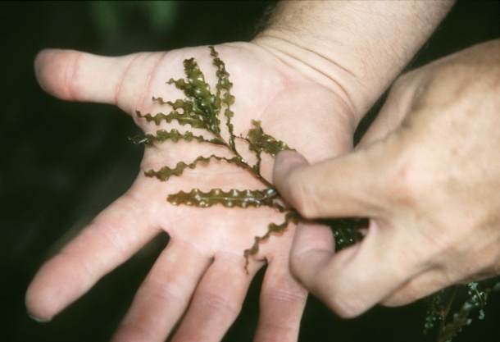
Curly leaf pondweed (Photo by Vic Ramey, University of Florida/IFAS Center for Aquatic and Invasive
Plants. Used with permission.)
* Addendum 2025. Later assessment of the aquatic plant community was completed by WDNR in June of 2009 and June 2013.
*Mead Lake has a below-average plant community based on AMCI¹ and FQI² values. FQI values suggest Mead Lake has been impacted by disturbance. Both AMCI and FQI values have decreased from 2009 to 2013 indicating a decline in the quality of the aquatic plant community. Appendix Pg29,30,31
1 - Aquatic Macrophyte Community Index
2 - Floristic Quality Index
*An aquatic plant survey is scheduled by WDNR for 2025.
*In 2024, and 2025, WDNR added Mead Lake to its Directed Lakes Initiative monitoring aquatic plants and water chemistry.
One important finding that can be reported is that no additional invasive plants, beyond curly leaf pondweed, were identified in the lake. It is significant that no specimens of the invasive species M. spicatum, or Eurasian water milfoil, were identified. This is important because many other lakes in the region report the presence of this aggressive invasive plant, and keeping it from entering Mead Lake will benefit the lake’s ecological community and help maintain a diverse native plant community beneficial for aquatic habitat.
Septic Systems
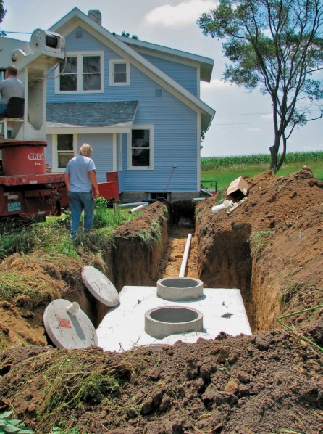
In 1996, Clark Co. applied for and received a WDNR grant to survey all private on-site wastewater treatment systems at the lake. In 1997 the survey was done by Ayres Associates in cooperation with the Clark Co. Planning and Zoning Department. The study showed that many of these systems were considered failing, or in some way not up to code.
Typical septic system being installed
Although the recommendation by Ayres was for a cluster treatment system at the lake, the residents instead chose to individually upgrade their systems. All failing systems at the lake were brought up to code after the study. However, a similar study has not been conducted for other septic systems within the watershed.
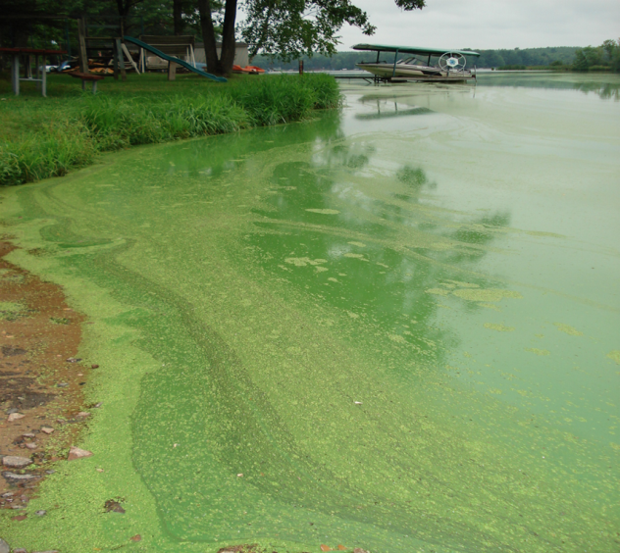
Note: Original goals and objectives from 2010 include annotations of updated information but are otherwise superseded to the updated Mead Lake Management Plan for 2025-2035.
See section Updated Mead Lake Management Goals and Objectives.

2010 Management Goals and Objective
Based on scientific research, sociological surveys, meetings with stakeholders, and other information about Mead Lake and its history, the following goals and objectives for the Mead Lake Management Plan will guide efforts in the future to insure a beautiful and healthy natural resource for years to come.
Severe algal bloom at Mead Lake
Goal 1: Improve water quality and decrease the frequency and intensity of algae blooms, by decreasing sediment and phosphorus inputs to the lake.
The TMDL for Mead Lake suggests that a 30% reduction in phosphorus and sediment loads delivered to the lake via runoff and tributaries is necessary to minimize algal blooms, increase the desirability of the water for full-body-contact recreation, such as swimming and water skiing, and to achieve compliance with water quality standards. This equates to a mean summer phosphorus concentration of 93µg/l (micrograms per liter). This would be a significant decrease from concentrations measured in 2002 and 2003 of approximately 130µg/l.*
*Update 2025. Phosphorus concentrations have increased 46% (avg 189 µg/l) in the summers of 2023 and 2024. Appendix- Trophic State Index
Since phosphorus is the limiting factor for algae growth, a reduction of sediment and phosphorus inputs to the lake should lead to a decrease in the number, intensity and duration of algal blooms.
Both the survey of lake residents and the intercept survey of lake users suggest that algal blooms and the poor water quality that results from these blooms is a concern for people who live and/or recreate at the lake.
The Mead Lake TMDL also states that the majority of phosphorus and sediment entering the lake and its tributaries originates from agricultural land, which comprises the largest percentage of land use in the watershed. Agricultural landowners will play a key role in the improvement of water quality at Mead Lake.
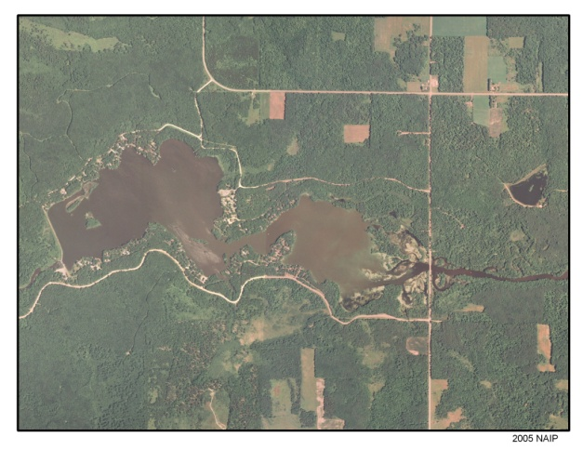
Objective 1) Watershed Restoration and Protection Strategy. Phosphorus and sediment have many sources in the lake’s watershed. A comprehensive watershed management plan will be developed that will address phosphorus and sediment sources. The management plan will include a targeted approach that focuses efforts on those lands that have the greatest need for conservation practice implementation and will respond most efficiently to practice implementation. This “needs-based response” analysis will help target limited staff and funding in those areas of the watershed that will provide the greatest conservation return for the time and money invested. Mead Lake is listed on the 303(d) list for impaired waters, therefore a watershed restoration and protection strategy will be designed and written to address not only the methods by which phosphorus and sediment loads will be reduced, but will also address the state and federal requirements related to the water quality impairments in Mead Lake.
Aerial photograph of Mead Lake and surrounding area
Much of the specific design of the strategy will hinge on the results of further survey work being done in spring and summer 2010 to determine the needs and concerns of producers in the watershed. Once this data is gathered, the watershed restoration and protection strategy will be completed, likely by early 2011. *Addendum 2025, Clark County initiated a new 3-5 year survey in 2025. See references. The strategy will; define sources of funding for specific implementation projects/programs; identify agencies or entities responsible for different phases of implementation; provide estimates of load reductions achievable through various approaches, and; include a timeline for when the various phases of implementation will be achieved. Implementation of this strategy will be carried out by the Partnership and cooperating entities.
Objective 2) Apply for Surface Water Grants. Much of the work necessary to implement the watershed management of phosphorus and sediment will take additional staff resources above and beyond what is currently available and require cost-share funds to assist farmers living in the watershed with conservation practice implementation. Therefore, once this Lake Management Plan is approved, the Partnership will seek Lake Protection Grants to provide cost-share funds for targeted sources of phosphorus and sediment within the watershed. *Addendum 2025, in 2020, Lake Protection Grant is replaced by Surface Water Restoration Grant
Objective 3) Groundwater Testing. There is a lack of data regarding the quality of groundwater within the watershed and a lack of knowledge by lake residents about the quality of groundwater in their wells. The state does not perform regular testing of private wells within the watershed. Therefore; a concerted effort to test groundwater within the watershed will be pursued by the Partnership with help from Clark County. Groundwater conditions may help determine if any phosphorus load might be moving to the lake due to soil saturation of phosphorus near the lake or stream tributaries.
Objective 4) Education. According to the sociological surveys conducted by the Partnership, there are many areas where knowledge regarding the sources of phosphorus and sediment is lacking. Furthermore, there is less knowledge regarding management techniques that can be used to reduce nutrient and sediment loads, such as shore land riparian buffers or the planting of cover crops on agricultural fields. Therefore, more work in educating those living at the lake and in the watershed, as well as those visiting the lake, will be undertaken. Much of this work is underway by the Partnership through their monthly meetings, press releases to local media, and word of mouth through the fairly small lake community. *Kiosks will also be installed at the lake in 2010 for display of educational materials.*Addendum 2025 -project complete.
Goal 2: Increase natural vegetation to produce biologically productive shore land that minimizes erosion and enhances natural aesthetics.
In the most recently available shoreline land use survey (Konkel, 1998) the type of shoreline land cover with the highest percentage of occurrence was cultivated lawn. Additionally, the information gathered from the survey of lake residents showed that most residents held a negative opinion toward shoreline riparian buffers. This information indicates that the lake may benefit from increasing the amount of natural vegetated cover along shorelines. However, it is necessary to educate lake property owners about how these buffers are beneficial, how to install them, and how they can be made more aesthetically pleasing.
Objective 1) Survey Current Lakeshore Riparian Conditions.* Addendum 2025. Mead Lake riparian property owners were notified in 2024 of available Healthy Lakes grants to offset expenses of shoreline vegetation improvements. Three Mead Lake property owners have agreed to participate as recommended by WDNR Directed Lakes shoreland assessment.
Since no official inventory has been conducted in over a decade, the amount of natural vegetative cover on the lake’s shoreline most likely has changed since the most recent 1997 survey. Newer data would be beneficial to help understand the contribution of shoreline erosion and/or runoff from lakefront properties to the lake’s phosphorus and sediment levels. The inventory could also provide valuable information that would assist with preventing the loss of lake front property due to erosion. The Partnership will work with Clark County and the DNR to assess the lake’s shoreline. This inventory may be completed by staff, through volunteer work or via a contracted service. *A Lake Planning Grant will be necessary to fund this activity and will be applied for in 2010. *Addendum 2025 -project incomplete.
Objective 2) Installation of Vegetated Shore Land Buffers. In order to increase the number of installed riparian buffers and the percentage of shoreline covered by natural vegetation, education of lake residents will be an important first step. As identified in the lakefront property owner survey, there are obstacles to overcome, especially regarding the view of lake residents toward riparian buffers. The Partnership will work with natural resource professionals to inform and educate lake residents about the benefits of riparian buffers and how to properly install and maintain them. *Addendum, A workshop for lake residents was conducted in May 2024.
Goal 3: Maintain healthy fishery with desirable species, and a diverse native aquatic plant community.
Biological surveys of the Mead Lake fishery over the last twenty years show that the current condition of the fishery is fairly good. While there are a few desirable species that showed some decline in size or number (e.g. bluegills, perch), the fishery is quite productive. Carp, an undesirable species that is troublesome in other lakes, show a fairly low occurrence. The aquatic plant community also appears to be quite diverse with only one invasive species occurring (curly leaf pondweed). However, many survey respondents indicated they thought the lake had too many “weeds” that interfered with recreational activities and lake aesthetics.
Objective 1) New Lake Map. The Partnership discussed the possibility of creating a new lake map showing bathymetric data, lake bed characteristics, and physical habitat locations and characteristics. The geography department at University of Wisconsin – Eau Claire has produced such maps for other area lakes in the past. The Partnership will pursue creating a map for Mead Lake at the earliest date available. A Lake Planning Grant from the state and/or possible funding from the Mead Lake District will be necessary to pay for this work. Discussions are currently underway with UW-Eau Claire to determine how soon such a map can be produced.
Black Crappie (painting by Virgil Beck)
Objective 2) Promote A More Self Sustaining Fishery. The most recent survey inventoried bluegill at a lower density in recent years, and demonstrated that stocking is still necessary for walleye and musky. The promotion and development of spawning habitat would help in maintaining these populations on a more self-sustaining scale. A bathymetric map would provide data on the current location/condition of spawning habitat. Fish cribs and other near shore woody debris may also assist in increasing spawning habitat. The Partnership will work with local natural resource professionals to pursue the knowledge and resources necessary to determine if this is a viable alternative for the lake.
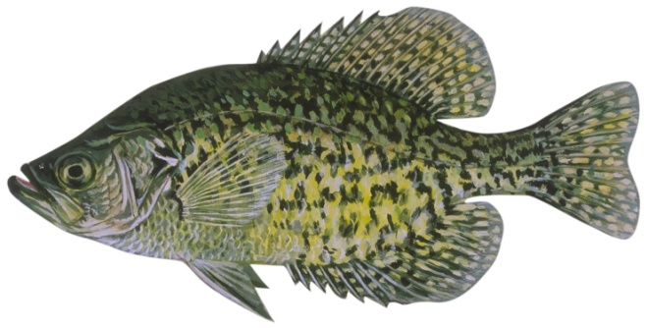
Objective 3) Education. It’s important for those who recreate at the lake to understand the condition of the lake’s resources, including fish and aquatic plants. The Partnership will work to educate those living on and using the lake regarding the current state of the fishery and what can be done to help maintain it. As fish surveys are completed by WDNR, this information will be made available to lake residents and visitors. Additionally, there is a need to educate lake users and residents on the value of a diverse aquatic plant community that provides habitat, cycles nutrients, and outcompetes invasive species.
Goal 4: Prevent expansion and new infestation of invasive and exotic species.
Currently the only invasive species known to be present in Mead Lake is curly leaf pondweed (P. crispus). Although it has not grown to a nuisance condition, curly leaf pondweed has likely been present in the lake for at least twelve years. Work must be undertaken to keep this species from spreading to more areas within the lake, and also to keep other invasive species, such as Eurasian water milfoil (M. spicatum), a species that is present in many other area lakes, from entering Mead Lake.
Objective 1) Monitoring. It’s important to know the extent of any invasive population/infestation that enters or is already present in the lake. For that reason, continuous monitoring for invasive species must take place. The partnership will work with the WDNR, lake monitoring volunteers, and others to continually monitor the lake for the occurrence or spread of invasive species.
*To be surveyed in 2025, WDNR will complete in Directed Lakes program
Objective 2) Education. It is important to keep curly leaf pondweed from moving to
other parts of Mead Lake or to other lakes in the region and also to prevent the spread of other invasives into Mead Lake. The Partnership will work with the WDNR, Clark County, the Clean Boats Clean Waters program, and other educational outlets to educate boaters and fishing enthusiasts regarding the cleaning of their boats before entering into or exiting Mead Lake. Instructional workshops for Clean Boats Clean Waters are being conducted in the region many times during 2010, and members of the partnership will attend these workshops to receive instruction.
In addition to plants, species such as zebra mussel (D. polymorpha) and rusty crayfish (O. rusticus) also need to be kept out of the lake, and any education program will address these and other aquatic and terrestrial invasive species as well. The educational kiosks, once installed, will be an excellent way to post such information for those visiting the lake.
The golden age of water skiing at Mead Lake.
Goal 5: Provide safe, diverse recreational opportunities for all.
In addition to those folks living on the lake, people come from many places, near and far, to recreate on Mead Lake. Many survey respondents indicated that at one time or another they avoided certain activities on the lake due to poor water quality. Many respondents expressed a concern with contacting the water when it is covered with a thick algal bloom. In order to increase the amount of body-contact recreation days, the water quality must be improved by decreasing the phosphorus and sediment load entering into Mead Lake. Additionally, there are other recreational challenges that the Partnership may address in the future.
Objective 1) Beach. Currently the lake has no user-friendly beach area. A quality beach with sand would provide better opportunities for swimming and shore land recreation. The Partnership will investigate the possibility of adding such a public beach at the lake. The Clark County Forestry and Parks Department has expressed an interest in improving the existing recreational areas, including the small beach area located at the campground. *Current discussions indicate this task could be accomplished in 2010. *Addendum, completed by Clark County.
Objective 2) Boating Regulations. The Partnership will assess the need for any additional boating regulations focusing on protecting erodible shore land, or re-suspension of bottom sediments that contain phosphorus and contribute to algae blooms. Boating safety is also an issue on many area lakes, and the Partnership will explore how to get some of its members certified as boating safety instructors.
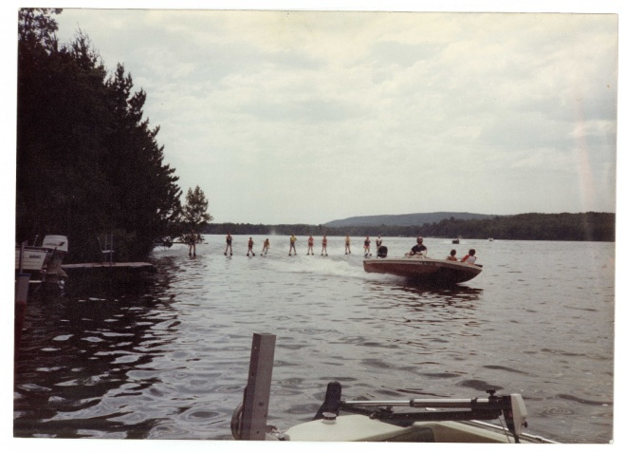
*Addendum: in 2024, per WDNR Permit, No Wake Markers, were placed in the Narrows area, to help ensure boater compliance with state regulations.
The golden age of water skiing at Mead Lake

Appendices
Dissolved Oxygen Data Pg 24, 25
Map of Mead Lake Test Points for Oxygen Pg 26
Dissolved Phosphorus and Chlorophyll-a Pg 26
Project costs - Lake Water Testing Pg 27
Laboratory Expense Pg 27
Technical Data NanoBubble Generator Pg 28
Aquatic Plan Community 2013 Analysis Pg 29-31
References Pg 32
Public and WDNR Comment Pg 33

Appendix of Dissolved Oxygen
Test Date |  |  | Dissolved oxygen and Temperature at Test Depth
6/8/24 |  |  | Surface 6"-10" |  |  | Mid-point |  | 1-2 ft above max depth |  |  | Bottom
Location | Max Dpth ft | Secchi  ft | Temp @ F | DO  ppm |  | Temp @ F | DO  ppm |  | Temp @ F | DO  ppm | DO Saturation
Adler Bay | 4 |  | 69.1 | 11.17 |  | na | na |  | 67.6 | 6.54 | 59%
East Southside Point | 10 |  | 69.1 | 11.03 |  | 67.5 | 7.12 |  | 64.8 | 0.17 | 2%
Narrows East | 14 |  | 68.9 | 11.6 |  | 67.6 | 7.4 |  | 65.7 | 5.32 | 46%
Deep Hole 3 Wisker | 14 |  | 69.1 | 10.96 |  | 66.7 | 4.98 |  | 62.6 | 0.22 | 2%
Deep Hole 2 | 14 |  | 68.5 | 10.25 |  | 66.9 | 4.98 |  | 63.3 | 0.16 | 2%
Deep Hole 1 by Dam | 15 |  | 68.0 | 10.2 |  | 66.7 | 5.29 |  | 61.2 | 0.26 | 3%

Test Date |  |  | Dissolved oxygen and Temperature at Test Depth
6/14/24 |  |  | Surface 6"-10" |  |  | Mid-point |  | 1-2 ft above max depth |  |  | Bottom
Location | Max Dpth ft | Secchi  ft | Temp @ F | DO  ppm |  | Temp @ F | DO  ppm |  | Temp @ F | DO  ppm | DO Saturation
Adler Bay | 4 | 2 | 72.1 | 11.28 |  | na | na |  | 66.2 | 6.72 | 60%
East Southside Point | 10 |  | 73.6 | 13.22 |  | 66.2 | 7.08 |  | 64.8 | 2.23 | 17%
Narrows East | 14 |  | 74.7 | 12.47 |  | 68.0 | 7.56 |  | 65.3 | 4.02 | 32%
Deep Hole 3 Wisker | 14 |  | 75.6 | 11.01 |  | 67.6 | 4.73 |  | 65.5 | 2.55 | 23%
Deep Hole 2 | 14 |  | 73.4 | 10.01 |  | 67.8 | 4.04 |  | 64.4 | 0.16 | 2%
Deep Hole 1 by Dam | 15 | 2.5 | 75.0 | 10.92 |  | 68.5 | 6.57 |  | 63.3 | 0.18 | 2%

Test Date |  |  | Dissolved oxygen and Temperature at Test Depth
7/21/24 |  |  | Surface 6"-10" |  |  | Mid-point |  | 1-2 ft above max depth |  |  | Bottom
Location | Max Dpth ft | Secchi  ft | Temp @ F | DO  ppm |  | Temp @ F | DO  ppm |  | Temp @ F | DO  ppm | DO Saturation
Adler Bay | 4 | 1.5 | 78.6 | 11.36 |  | na | na |  | 76.3 | 4.88 | 43%
East Southside Point | 10 | 2 | 76.8 | 8.5 |  | 72.5 | 2.26 |  | 66.9 | 0.16 | 2%
Narrows East end | 14 | 2 | 79.0 | 10.67 |  | 68.7 | 0.17 |  | 65.8 | 0.19 | 2%
Deep Hole 3 Wisker | 14 | 1.5 | 78.8 | 10.77 |  | 71.6 | 2.34 |  | 66.2 | 0.17 | 2%
Deep Hole 2 | 14 | 2 | 78.8 | 10.97 |  | 72.0 | 1.04 |  | 65.7 | 0.19 | 2%
Deep Hole 1 by Dam | 15 | 2.3 | 78.6 | 10.98 |  | 71.1 | 0.86 |  | 65.1 | 0.16 | 1%

Appendix of Dissolved Oxygen, con’t

Test Date |  |  | Dissolved oxygen and Temperature at Test Depth
7/30/24 |  |  | Surface 6"-10" |  |  | Mid-point |  | 1-2 ft above max depth |  |  | Bottom
Location | Max Dpth ft | Secchi  ft | Temp @ F | DO  ppm |  | Temp @ F | DO  ppm |  | Temp @ F | DO  ppm | DO Saturation
Adler Bay | 4 | 1.5 | 72.5 | 6.96 |  | na | na |  | 69.4 | 5.38 | 77%
East Southside Point | 10 | 2 | 77.4 | 9.9 |  | 70.7 | 5.37 |  | 69.3 | 5.01 | 51%
Narrows East end | 14 | 2 | 77.0 | 9.55 |  | 70.2 | 5.21 |  | 69.4 | 4.7 | 49%
Deep Hole 3 Wisker | 14 | 2 | 77.4 | 14.73 |  | 72.7 | 5.38 |  | 70.3 | 5.4 | 37%
Deep Hole 2 | 14 | 1.8 | 79.3 | 12.94 |  | 72.3 | 2.44 |  | 69.4 | 0.22 | 2%
Deep Hole 1 by Dam | 15 | 2 | 78.4 | 11.82 |  | 71.8 | 1.09 |  | 68.2 | 0.16 | 1%

Test Date |  |  | Dissolved oxygen and Temperature at Test Depth
8/13/24 |  |  | Surface 6"-10" |  |  | Mid-point |  | 1-2 ft above max depth |  |  | Bottom
Location | Max Dpth ft | Secchi  ft | Temp @ F | DO  ppm |  | Temp @ F | DO  ppm |  | Temp @ F | DO  ppm | DO Saturation
Adler Bay | 4 | 1.5 | 79.7 | 16.98 |  | na | na |  | 70.5 | 7.7 | 45%
East Southside Point | 10 | 2 | 78.3 | 17.55 |  | 68.2 | 6.44 |  | 66.4 | 3.59 | 20%
Narrows East end | 14 | 2 | 82.4 | 18.35 |  | 68.7 | 6.65 |  | 66.4 | 4.08 | 22%
Deep Hole 3 Wisker | 14 | 2 | 75.2 | 13.48 |  | 66.6 | 2.99 |  | 65.3 | 0.77 | 6%
Deep Hole 2 | 14 | 2 | 74.3 | 17 |  | 68.0 | 6 |  | 64.9 | 0.48 | 3%
Deep Hole 1 by Dam | 15 | 2 | 75.9 | 15.22 |  | 67.1 | 4.83 |  | 65.5 | 1.71 | 11%

Test Date |  |  | Dissolved oxygen and Temperature at Test Depth
9/8/24 |  |  | Surface 6"-10" |  |  | Mid-point |  | 1-2 ft above max depth |  |  | Bottom
Location | Max Dpth ft | Secchi  ft | Temp @ F | DO  ppm |  | Temp @ F | DO  ppm |  | Temp @ F | DO  ppm | DO Saturation
Adler Bay | 4 | 1.5 | 68.0 | 13.79 |  | na | na |  | 66.0 | 10.2 | 74%
East Southside Point | 10 | 1.5 | 67.8 | 12.65 |  | 67.5 | 12.38 |  | 64.0 | 7.32 | 58%
Narrows East end | 14 | 1.5 | 68.4 | 12.94 |  | 67.3 | 12.11 |  | 65.7 | 8.3 | 64%
Deep Hole 3 Wisker | 14 | 1.5 | 68.0 | 12.4 |  | 67.3 | 10.86 |  | 65.8 | 7.26 | 59%
Deep Hole 2 | 14 | 1.5 | 67.6 | 9.66 |  | 67.3 | 8.9 |  | 66.6 | 6.74 | 70%
Deep Hole 1 by Dam | 15 | 1.5 | 68.0 | 8.14 |  | 65.8 | 4.86 |  | 65.7 | 4.83 | 59%

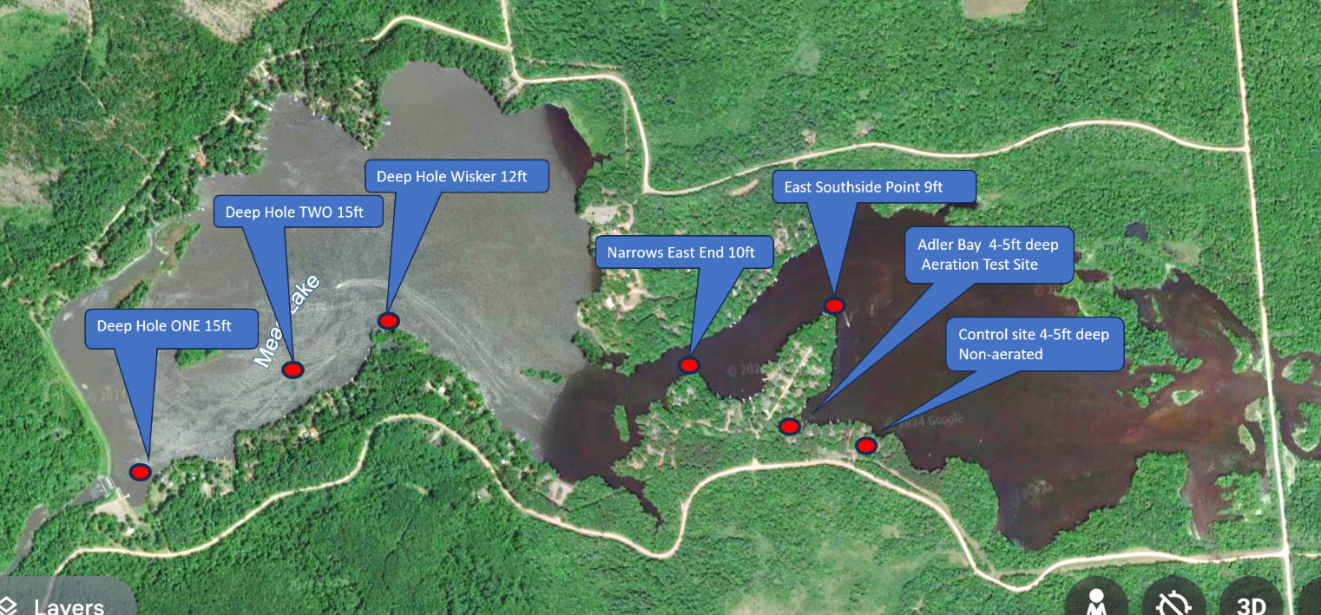
Map of Mead Lake Test Points for Dissolved Oxygen and Aeration Test Sites
Appendix of Dissolved Phosphorus and Chlorophyll a
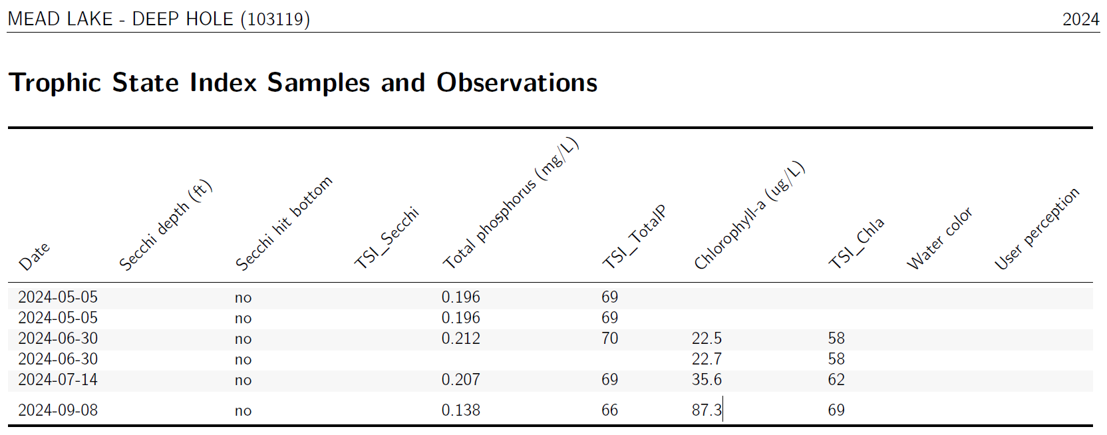
Phosphorus standard 40ug/L .04mg/L
Chlorophyll-a standard 20ug/l
ug/L = microgram per liter
mg/L = milligram per liter
Phosphorus standard 40ug/L .04mg/L
Chlorophyll-a standard 20ug/l
ug/L – microgram per liter
mg/L = milligram per liter
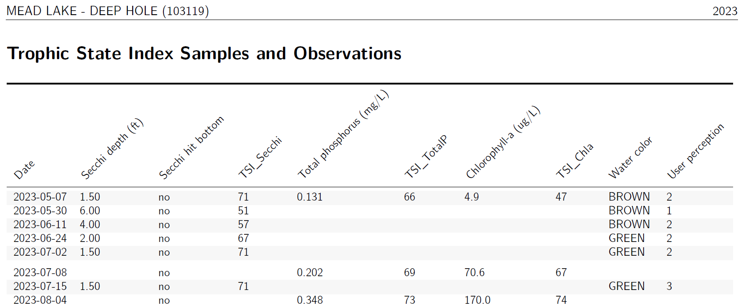
Appendix of Annual Cost for Lake Water Testing
List of required annual water sampling parameters and laboratory test expense.
- Aeration Test site and non-aerated control site are 4-5 feet deep
- Surface samples will be collected from the top 12inches. Bottom samples will be collected 6 inches from the bottom.
- Two rounds of samples (i.e. one month) will be collected prior to operating the nanobubble unit.
- All samples will be collected by Mead Lake volunteers using WDNR equipment. Multiple volunteers will be trained by the WDNR to ensure samples are consistently collected.

In November 2024 Mead Lake District submitted a Surface Water Planning grant application to offset laboratory expenses. State share is 67% with a cap of $10,000.
The grant application was not funded by WDNR.

List of Non-funded laboratory expense and volunteer value.
Appendix- Technical Data NanoBubble Generator
NanoBubble technology is used for lake restoration and rehabilitation. NanoBubbles concentrated oxygen aeration technology supersaturates water with ambient oxygen. Nanobubbles machinery pulls in lake water and returns oxygen concentrated water into the lake. Supersaturated oxygenated water reduces potential for algae blooms, reduces levels of excessive nutrients, (phosphorus, chlorophyll-a) and increases the natural decomposition of organic material in muck. Water clarity will also improve.
All NanoBubbles machinery is located on land. No equipment including water inlet and discharge piping is affixed or anchored to the lake bottom.
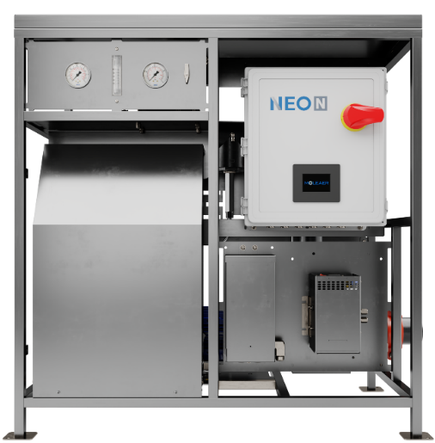
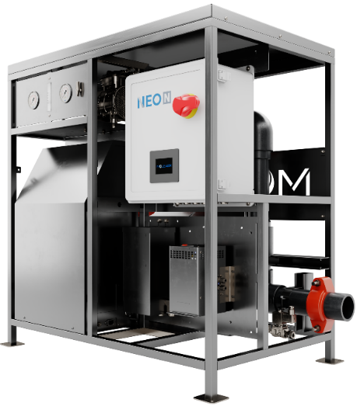

NanoBubble Generator with Oxygen Concentrator
www.Moleaer.com
Manufacturer Model | Neo N
Water Flow Rate – GPM (gallon per minute | 110-115
Electrical power – 3hp motor | 230 volts, single phase, 16.3amp  460 volts, three phase, 8.3amp
Estimated Electrical Expense – growing season*  *Provided by Clark Electric Cooperative | *$949 Single phase  *$569 Three phase
Pipe size and type – inlet and discharge | Three inch - PVC
Weight (lbs.) | 320
Dimensions (in) | 42L x 26W x 43.6H
Supplier | Lake Restore, Blain, MN, Lakerestore.com

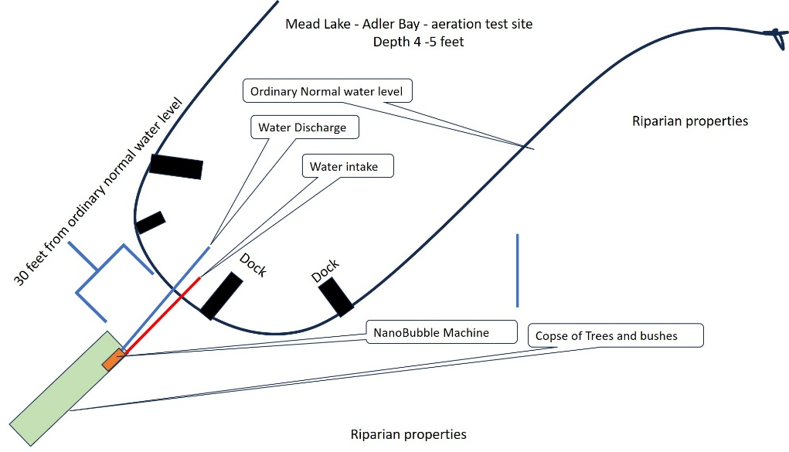
Adler Bay - Location of NanoBubble Aeration

Appendix - Aquatic Plant Community 2009 and 2013 Analysis
Aquatic Plant Surveys were conducted on Mead Lake in June 2009 and June 2013 by water resources staff at the Wisconsin Department of Natural Resources. An aquatic plant survey was also conducted in 1998; however, this survey was conducted using methods different from those used in the current surveys so results are not compared. The plant survey was conducted according to the Wisconsin Department of Natural Resources Guidelines using the Point–Intercept method that can be found at http://www.uwsp.edu/cnr/uwexlakes/ecology/APM/Appendix-B.pdf. A 64 meter grid of 339 points was used in 2009 and a 48 meter grid of 551 points was used in 2013. At each Point-Intercept point one sample was collected using a steel thatching rake. The aquatic plant species present on the rake were identified and recorded. Each species was given a density rating based on the total coverage of the plant on the rake (1 – few, 2 – moderate, 3 – abundant). Visual inspections were done between points to record the presence of any species that did not occur at the sampling sites.
The Aquatic Macrophyte Community Index (AMCI) was used to define the quality of the aquatic plant community based on seven parameters: the maximum rooting depth, the percentage of the littoral zone vegetated, the relative frequencies of submerged species, sensitive species and exotic species, Simpson’s Diversity Index and the total number of taxa. Each parameter was scaled from 1-10 with 10 representing the most desirable condition. The scaled values were then summed to obtain the AMCI.
The Floristic Quality Index (FQI) was used to assess each community’s resemblance to an undisturbed condition. Coefficients of conservatism are values assigned to plant species based on their ties to a pre-settlement condition. Plants are given a value on a scale of 1 to 10 based on the probability that a species will occur in a disturbed habitat with higher values given to plants that are less likely to occur in a disturbed habitat. Coefficient of conservatism values are assigned only to native species that would normally be found in a lake environment. FQI = Average Coefficient of conservatism * √Number of species
Simpson’s Diversity Index (SDI) was used to measure the diversity of the plant communities in each survey. The formula measures the probability that two individuals from the same community will be the same species. Values for SDI range from 0-1 where a value of 0 indicates two individuals will always be the same species and a value of 1 indicates two individuals will always be different species.
SDI = 1 - (Sum (frequency of occurrence of one species/sum frequency of all species))

Macrophyte data
Twenty-two species were found in Mead Lake over both sampling periods (Table 1). Submerged vegetation was the most commonly found vegetation type. Two species considered sensitive to disturbance were found; Potamogeton foliosus (2009) and P. zosteriformis (2009 and 2013). Two invasive species, P. crispus and Phalaris arundinacea, were found during both surveys.
Mead Lake’s AMCI and FQI values were compared to lakes in Wisconsin, and the Northern Central Hardwood Forests (NCHF) region. Box plots illustrate where Mead Lake falls on the continuum of values. The graphic to the right illustrates the box plot. The minimum and maximum represent the lowest and highest values. 25% of lakes fall above and below the upper and lower quartile marks and 50% of lakes fall above and below the median value.
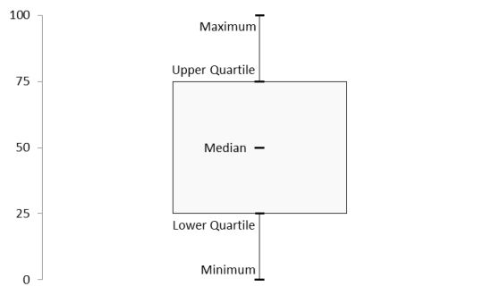

Macrophyte data – con’t
Mead Lake fell in the lower quartile for both AMCI (Table 3 and Figure 11) and FQI (Table 4 and Figure 12) values when compared to both Wisconsin lakes and lakes in the North Central Hardwood Forest region. Most individual statistics comprising the AMCI and FQI fell below the median value to the lower quartile. The only statistic to fall in the upper quartile was the relative percent frequency of invasive species. All statistics decreased from 2009 to 2013 except the relative percent of submergent species.
Aquatic Macrophyte Community Index (AMCI) | 2009 |  | 2013
Aquatic Macrophyte Community Index (AMCI) | Value | Scaled | Value | Scaled
Maximum Rooting Depth (ft) | 9.5 | 4 | 7.5 | 3
# Species | 19 | 8 | 13 | 6
Littoral Zone Vegetated (%) | 42.59 | 8 | 28.03 | 3
Submergent Species (%) | 59.01 | 5 | 80.66 | 10
Sensitive Species (%) | 10.56 | 6 | 4.94 | 5
Exotic Species (%) | 12.73 | 4 | 13.17 | 4
Simpson's Diversity | 87.78 | 8 | 85.82 | 7
AMCI |  | 43 |  | 38
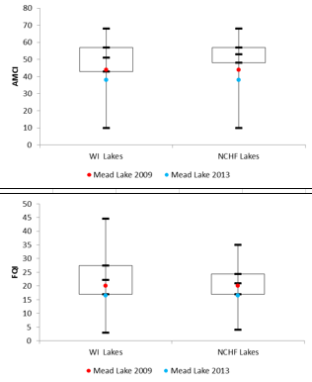

Floristic Quality Index (FQI) | 2009 | 2013
Species | 16 | 11
Average C | 5.0 | 5.0
FQI | 20.00 | 16.58

Summary Findings of 2009 - 2013
Mead Lake has a below-average plant community based on AMCI and FQI values. FQI values suggest Mead Lake has been impacted by disturbance. Both AMCI and FQI values have decreased from 2009 to 2013 indicating a decline in the quality of the aquatic plant community. Aquatic plant surveys are scheduled by WDNR for 2025; including a partial survey of the aeration test and non-aerated control sites prior to operating the Nanobubble unit and a full lake survey mid-summer.
References
Blasczyk, J. and David J. Summers. 2009. The Mead Lake Property Owners: Their Views on Water Quality of the Watershed and Their Management Practices. Environmental Resources Center, University of Wisconsin, Madison, WI.
Blasczyk, J. and Rachel Ford. 2009. Mead Lake Intercept Survey Results. Environmental Resources Center, University of Wisconsin, Madison, WI.
Friehofer, Adam. 2006. Mead Lake Watershed SWAT Model Setup. Center for Watershed Science and Education, University of Wisconsin - Stevens Point, Stevens Point, WI.
Hatleli, D. 2009. Presentation to Mead Lake and Watershed Partnership on Fish Population Data, Mead Lake, WI. Presentation prepared by Wisconsin Department of Natural Resources.
Konkel, D. 1998. The Aquatic Plant Community of Mead Lake, Clark Co, WI. Prepared by Wisconsin Department of Natural Resources.
*Link to survey. Data made available by Clark County Conservation Department
https://www.arcgis.com/apps/dashboards/a0d3da11466d49bda4d1eb5c46013249.
Lovelace, B. and J. Lovelace-Voigt. 2002. A Collection of Mead Lake Nostalgia. Prepared by a committee of Mead Lake Residents.
*Original Mead Lake Management Plan 2010 https://apps.dnr.wi.gov/swims/Documents/DownloadDocument?id=165680346
Mead Lake Sanitary Septic Survey. 1997. Report prepared by Ayres Associates. Eau Claire, WI.
*Oxygen Levels, Mead Lake Summer 2024. Prepared by Mead Lake District, L. Koschak and P. Strand.
Schmidt, S. 2009. Raw data for Summer 2009 Mead Lake Aquatic Plant Study. Data made available by Wisconsin Department of Natural Resources.
Schreiber, K. and N. Richmond. 2008. Total Maximum Daily Load: Mead Lake, Clark Co, WI. Prepared by the Wisconsin Department of Natural Resources.
*Trophic State Index. Water test samples made available by Mead Lake Volunteer, L. Zepplin, Citizens Lake Monitoring Network. Data made available by the Wisconsin Department of Natural Resources.
*NR 102.03 Water Quality Standards For Wisconsin Waters. Chlorophyll-a and Phosphorus, Prepared by the Wisconsin Department of Natural Resources.
*Aquatic Plant Community 2009 and 2013 Analysis. Prepared by the Wisconsin Department of Natural Resources.

*indicates revised 2025 Mead Lake Management Plan
Photo Credits
Dan Zerr: cover, pages 1, 3
Courtesy of Mead Lake District: pages 2, 13
Matt Zoschke: page 10
National Agricultural Imagery Program: page 11
Peggy Compton: page 9
Vic Ramey: page 8
Land Cover Map, page 4, created by University of Wisconsin-Extension
Listing of Public Comments
Notice for 21 day public comment delivered via social media and Enterprise Sentinal.
Public comment period available from February 1, 2025 through March 4, 2025
Comments are submitted to meadlake1952@gmail.com
Comments addressed by Commissioner Phil Strand and District Volunteer Larry Koschak
All commenters received individual responses
- Would like to see more emphasis on Clark County efforts in the watershed
  - District: Table is updated in Goal 1, Objective 1, p. 7
- Confusing sentence – These excessive nutrients and lack of oxygen confirm the negative effect on preventing Algal blooms, muck decomposition on the lake bottom, including a negative impact on the fish habitat oxygen in the lake. Needs more clarification on how these facts are connected to the overall problems.
  - District: Text has been changed for clarification p.4 and 5.
- Why limit it to late season? Other lakes do a early summer and late fall installation cycle.
  - As written - p. 5, point 6,: Start a late season fish habitat improvement program with fish crib drops.
  - District: Point 6 reflects plan in 2025. Table Goal 3, Objective 2 promotes fish habitat improvement as on-going without specific seasonal timing.
- Could one of the action plans be to take drone footage after large rainfalls to document run-off sources within the watershed that feeds Mead Lake? The documentation could be used with the County and Town to try and address the sources of sediment/nutrients flowing onto the lake.
  - District: This is addressed in text, Goal 1, Objective 4.
- Should there be a "slow no wake" buoy(s) between the two large islands on the west end of the main lake? The distance between them seems to be less than the channel, the water is fairly shallow there, and it is a very common recreation spot for kayakers and fishermen.
  - District: This is addressed in text, Objective 5, Goal 2.
Statistics of social media public outreach comment period
713 members comprise the Social Media site
451 members reached the notice
141 members engaged with the notice and link to the document

Clarifications added as requested by WDNR
pg 4, 5, 28 Clarified aeration technology in test program is shoreland installed and (p26) there is no equipment anchored to the lake bed.
pg 5, Additional clarification is added that the project is Test and learn / Proof of concept / Feasibility test
pg 6, Added narrative: Following the completion of this two-year pilot, statistically significant changes in nutrient levels, sediment composition, biological communities, dissolved oxygen, and water clarity will inform adaptive lake management strategies. These strategies will support surface water restoration efforts between 2027 and 2030.
pg 7, 8, 9, Listed specific applicable grant to various objectives
pg 16, Added 2013 for aquatic plant survey
pg 26, Added location of control site and water depth at test site and control site
pg 27, DO test added to monthly test parameters
pg 27, Additional sediment cores samples added - 2x per month
pg 28, Added identification to cross section indicating location of inlet and discharge piping
pg 16, 29, 30, 31 Added Aquatic Plant Community Analysis

